In this session, basic HTML is introduced.
You may follow the instructions below, to create the basic HTML page with the appropriate elements.
Let’s start!
- HTML starter pack. You should have this starter pack ready for your exercises.
<!DOCTYPE html>
<html lang="en">
<head>
<meta charset="utf-8" />
<meta name="description" content="Demonstrates some basic HTML content elements" />
<meta name="keywords" content="HTML5, tags" />
<meta name="author" content="A Lecturer" />
<title>Lecture 1-2 - HTML 5 Basic Content Elements</title>
</head>
<body>

</body>

HEADER STYLES
- Create <h1> tag. Insert the scripting below after <body> tag. Header styles include <h1>, <h2>, <h3> to <h5>.
<h1>HTML 5 Elemens</h1>
<h1>HTML 5 Basic Content Elements</h1>

LINK within page (TEXT)
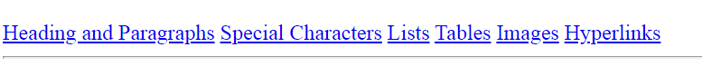

- Let’s create a text link as above. Insert the following scripts to create the hyperlink within page to each text.
<a href=" #headings">Heading and Paragraphs</a>
<a href="#sc">Special Characters</a>
<a href="#lists">Lists</a>
<a href="#tables">Tables</a>
<a href="#images">Images</a>
<a href="#hyperlinks">Hyperlinks</a>

PARAGRAPH
- Let’s work on the paragraph by using <p> tag. <h1> tag is reserved for header styles.
<p>HTML page without CCS styling looks a bit boring!!</p>

HEADER STYLES AND PARAGRAPH
- You can prepare your content by using header styles and paragraph together.
<h2>Headings and Paragraphs </h2>
<p>Headings and paragraphs are BLOCK elements</p>
<h3>Headings</h3>
<p>There are 6 levels of heading. Headings are logical marked. Do not skip levels. If you want to change the size of a heading, don't change its level - change the CSS.</p>
<h3>Paragraphs</h3>
<p>Paragraphs contain the body text of a web page. You cannot put another block element inside a paragraph.</p>

SPECIAL CHARACTER AND ID
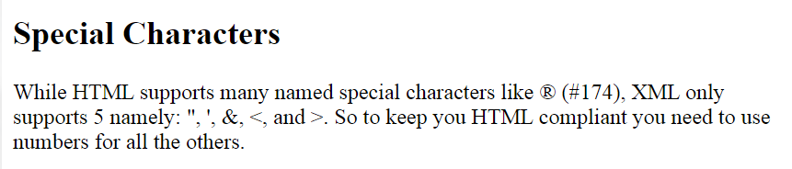
“ | &quot; | ‘ | &apos; | & | &amp; | < | &lt; | > | &gt;

- There are codes to use for special characters as above. You may find the codes used under <p> tag. We will assign an id to this section and name the section as ‘sc’. This id will be used as link above.
<h2 id="sc">Special Characters</h2>
<p>While HTML supports many named special characters like &#174; (#174), XML only supports 5 namely: &quot; , &apos;, &amp;, &lt;, and &gt;. So to keep you HTML compliant you need to use numbers for all the others.</p>

LISTING
- At this section, you will learn how to create number listing and bullet listing as below:
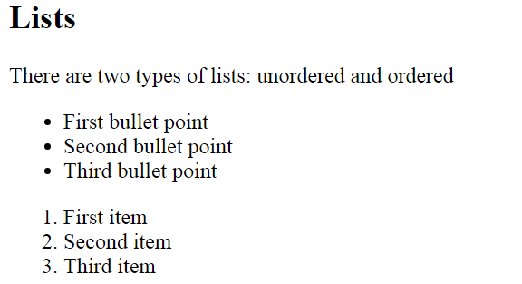

- Let’s start with bullet listing by using the following script. Before that, create an id to this section, name the id as ‘list’.
<h2 id="list">Lists</h2>
<p>There are two types of lists: unordered and ordered</p>
<ul>
<li>First bullet point</li>
<li>Second bullet point</li>
<li>Third bullet point</li>
</ul>

- Now, let’s continue with bullet listing by using the following script.
<h2 id="list">Lists</h2>
….
<ol>
<li>First item</li>
<li>Second item</li>
<li>Third item</li>
</ol>

- How about to work with nested listing?
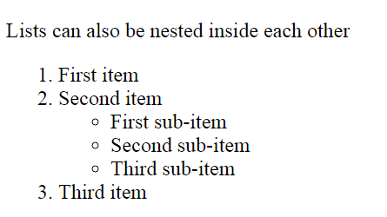

<h2 id="list">Lists</h2>
…
<p>Lists can also be nested inside each other</p>
<ol>
<li>First item</li>
<li>Second item</li>
<ul>
<li>First sub-item</li>
<li>Second sub-item</li>
<li>Third sub-item</li>
</ul>
</li>
<li>Third item</li>
</ol>

TABLE (ROWs and COLUMNS)
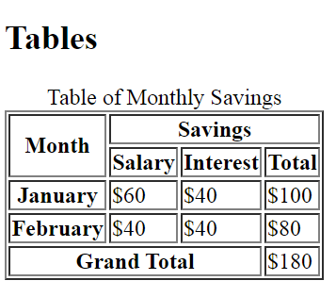

- Let’s create a table as above. Let me ask a question, how many rows and columns here? It is 5 rows x 4 columns. Let’s work it together. We will start with an id section following by <table> tag. Do remember to close the table tag by using </table>. <Caption> tag is used for the title for the table.

<h1 id="tables">Tables</h1>
<table border="1">
<caption>Table of Monthly Savings</caption>

</table>

- Now, let’s create 5 rows for this table.
<h1 id="tables">Tables</h1>
<table border="1">
<caption>Table of Monthly Savings</caption>
<tr></tr>
<tr></tr>
<tr></tr>
<tr></tr>
<tr></tr>
</table>

Row 1
- We will work on row by row. Using the following script will give you 2 columns for first row. <th> tag is used to format these cells in heading format with bold and center. We will do merging format for these 2 columns. First column merges with 2 rows (rowspan =”2”) and second column merges with 3 columns (colspan = “3”).
<h1 id="tables">Tables</h1>
<table border="1">
<caption>Table of Monthly Savings</caption>
<tr>
<th rowspan="2" scope="col">Month</th>
<th colspan="3" scope="col">Savings</th>
</tr>

<tr></tr>
<tr></tr>
<tr></tr>
<tr></tr>
</table>

Row 2
- Now using the following script for row 2.
<h1 id="tables">Tables</h1>
<table border="1">
<caption>Table of Monthly Savings</caption>
<tr>
<th rowspan="2" scope="col">Month</th>
<th colspan="3" scope="col">Savings</th>
</tr>

<tr>
<th scope="col">Salary</th>
<th scope="col">Interest</th>
<th scope="col">Total</th>
</tr>
<tr></tr>
<tr></tr>
<tr></tr>
</table>

Row 3 & 4
- Create row 3 & 4 with 4 columns by using the following script.

<h1 id="tables">Tables</h1>
<table border="1">
<caption>Table of Monthly Savings</caption>
<tr>
<th rowspan="2" scope="col">Month</th>
<th colspan="3" scope="col">Savings</th>
</tr>

<tr>
<th scope="col">Salary</th>
<th scope="col">Interest</th>
<th scope="col">Total</th>
</tr>
<tr>
<th scope="row">January</th>
<td>$60</td>
<td>$40</td>
<td>$100</td>
</tr>
<tr>
<th scope="row">February</th>
<td>$40</td>
<td>$40</td>
<td>$80</td>
</tr>
<tr></tr>
</table>

Row 5
- The last row of the table.
<tr>
<th colspan="3" scope="row"> Grand Total</th>
<td>$180</td>
</tr>

HYPERLINK (TEXT AND PICTURE)
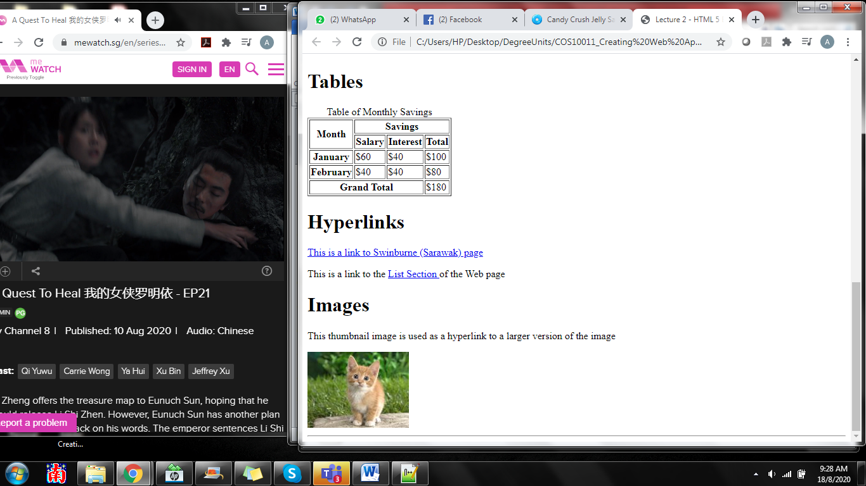

- Create a hyperlink (text) which link to a website.
<h1 id="hyperlinks">Hyperlinks</h1>
<p><a href="http://www.swinburne.edu.my" title="This takes you to Blackboard"> This is a link to Swinburne (Sarawak) page</a></p>
<p>This is a link to the <a href="#list">List Section </a> of the Web page</p>

- Lastly, insert a picture and using the picture as a link to another source.

<h1 id="images">Images</h1>
<p>This thumbnail image is used as a hyperlink to a larger version of the image</p>
<a href="mycat.jpg"> <img src="mycat_small.jpg" alt="Photo of my cat" title="Filesize 222kb " /></a>

